**Problem Statement 1**: Design a Half Adder Circuit and verify the truth table.

**Basic Explanation:** Half adder performs 2-bit addition.

**Half Adder Circuit:**

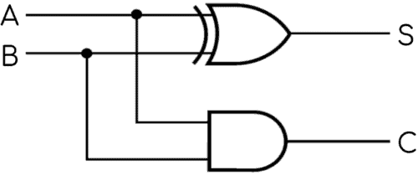

(Carry)

(sum)

**Truth Table:**

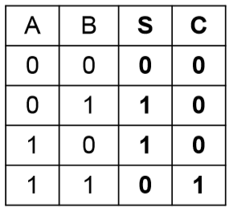

**Logical Expression:**

**Output:**

**HALF ADDER**



**Problem Statement 2**: Design a Full Adder Circuit and verify the truth table.



**Basic Explanation:** Full adder performs 3-bit addition.

**Full Adder Circuit:**

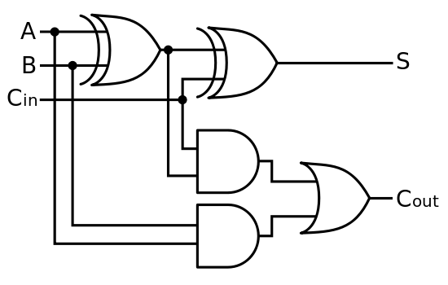

(sum)



**Truth Table:**

**Logical Expression:**

S = A′B′Cin+A′BCin′+AB′Cin′+ABCin

= (A′B+AB′)Cin′+(A′B′+AB)Cin

= (A⊕B)Cin′+(A⊕B)′Cin

= A⊕B⊕Cin

Cout = A′BCin+A′BCin′+ABCin′+ABCin

= Cin(A′B+AB′)+AB(Cin′+Cin)

= AB+Cin(A⊕B)

**Outputs:**

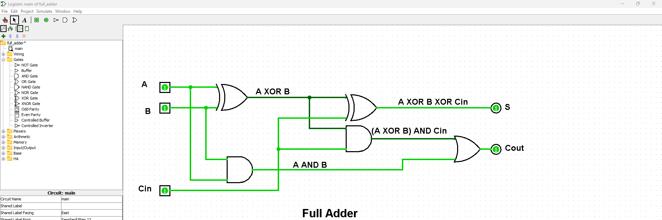

**FULL ADDER**

**Problem Statement 3**: Design a Half Subtractor Circuit and verify the truth table.

**Basic Explanation:** Half Subtractor performs 2-bit subtraction.

**Half Subtractor Circuit:**

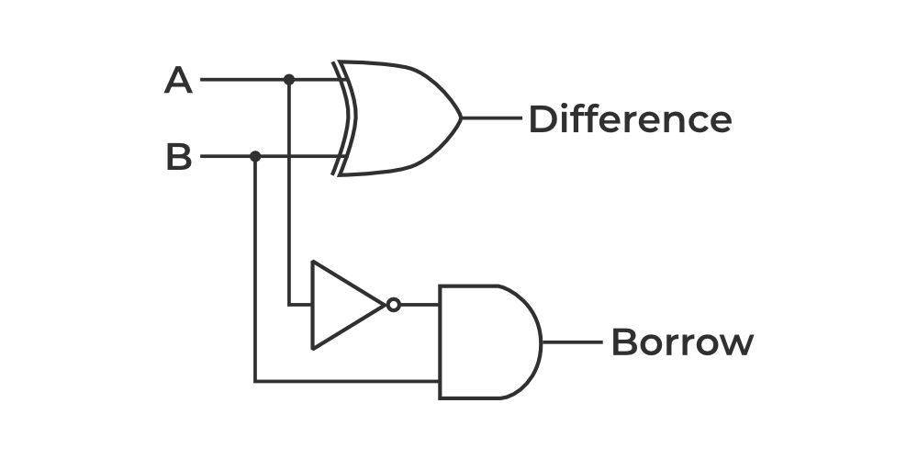

(d)

(b)

**Truth Table:**

**Logical Expression:**

**Output:**

**HALF SUBTRACTOR**

**Problem Statement 4**: Design a Full Subtractor Circuit and verify the truth table.



**Basic Explanation:** Full Subtractor performs 3-bit subtraction.

**Full Subtractor Circuit:**

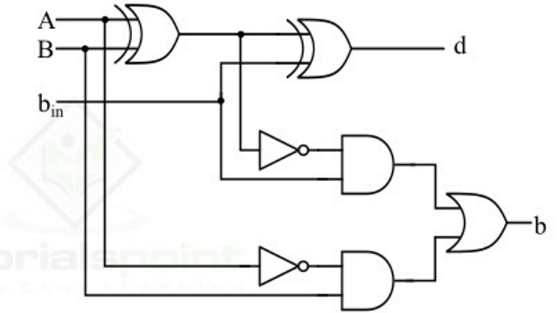



out

(Difference)



**Truth Table:**

**Logical Expression:**



d=A′B′bin+A′Bbin′+AB′bin′+Abbin

=(A′B+AB′)bin′+(A′B′+AB)bin

=(A⊕B)bin′+(A⊕B)′bin

=A⊕B⊕bin

bout=A′B′bin+A′Bbin′+A′Bbin+Abbin

=A′B(bin′+bin)+(A′B+AB′)bin

=A′B+(A⊕B)′bin

**Output:**

**FULL SUBTRACTOR**

**Problem Statement 5**: Design a 4-bit Ripple Carry Adder Circuit and verify the result.



**Basic Explanation:** 4-bit Ripple Carry Adder performs addition of two 4-bit binary numbers.

**Ripple Carry Adder Circuit:**



**Output:**

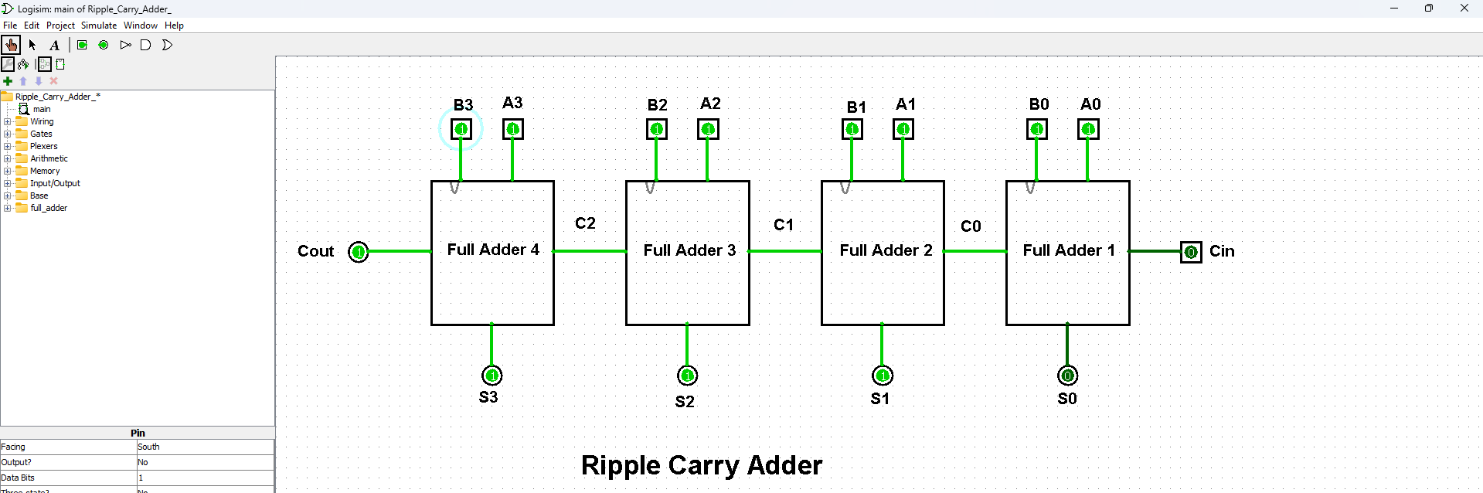

**RIPPLE CARRY ADDER**

**Problem Statement 6**: Design a 4-bit Incrementer Circuit and verify the result.



**Basic Explanation:** 4-bit Incrementer increases a 4-bit number by 1 unit.

**4-bit Incrementer Circuit:**



**Output:**

**BINARY 4-BIT INCREMENTER**

**Problem Statement 7**: Design a Carry Look Ahead Adder and verify the result.



**Basic Explanation:** Carry Look Ahead Adder performs addition of two n-bit numbers only using initial carry C0.

**Full adder circuit diagram:**

**IC diagram of Full adder :**

**CLA generator circuit diagram :**

**IC diagram of CLA Generator:**

**Carry Look Ahead Adder** **Circuit:**



**Output:**

**CARRY LOOK AHEAD ADDER**

**Problem Statement 8**: Design a 4-bit Adder – Subtractor composite unit and verify the result.



**Basic Explanation:** 4-bit Adder – Subtractor composite unit performs addition as well as subtraction of two 4-bit numbers.

**4-bit Adder – Subtractor composite unit Circuit:**

SW



**Output:**

**4-BIT ADDER-SUBTRACTOR COMPOSITE UNIT**

**Problem Statement 9**: Design a 4-bit decrementer Circuit and verify the result.



**Basic Explanation:** 4-bit decrementer circuit decreases a 4-bit number by 1 unit.

**4-bit decrementer Circuit:**



**Output:**

**4-BIT DECREMENTER CIRCUIT**

**Problem Statement 10**: Design a 4-bit Arithmetic unit and verify the result.



**Basic Explanation:** 4-bit Arithmetic unit performs 7 different operations.

**4-bit Arithmetic Unit:**



**Truth Table:**



**Output:**

**4-BIT ARITHMETIC UNIT**